Civil war in Georgia

UNSC Resolution: | 906
Date of adoption: | 25-Mar-1994
Operative paragraph: | 2
Demand number: | 906.0211

David Siroky

Wording of demand

respect the sovereignty and territorial integrity of the Republic of Georgia

List of addressees of the demand

Abkhazia

Short-term compliance

Description of the addressee(s)’ conduct

the Abkhaz side is taking political positions that prevent those conditions from being met. Thus, by not acceding to the Council’s demand that all concerned recognize the territorial integrity of Georgia, the Abkhaz side is in effect preventing the United Nations
from responding to a call for assistance from a Member State and blocking the orderly return of refugees (S/1994/253, p. 5, par. 2)”
the Abkhaz side is taking political positions that prevent those conditions from being met. Thus, by not acceding to the Council’s demand that all concerned recognize the territorial integrity of Georgia, the Abkhaz side is in effect preventing the United Nations
from responding to a call for assistance from a Member State and blocking the orderly return of refugees (S/1994/253, p. 5, par. 2)”

Assessment

Short-term compliance
No or marginal compliance (1) | Medium low compliance (2) | Medium high compliance (3) | Full or almost full compliance (4)

Considerations underlying the assessment

Medium-term compliance

Description of the addressee(s)’ conduct

the Abkhaz side is taking political positions that prevent those conditions from being met. Thus, by not acceding to the Council’s demand that all concerned recognize the territorial integrity of Georgia, the Abkhaz side is in effect preventing the United Nations
from responding to a call for assistance from a Member State and blocking the orderly return of refugees (S/1994/253, p. 5, par. 2)”

Assessment

Medium-term compliance
No or marginal compliance (1) | Medium low compliance (2) | Medium high compliance (3) | Full or almost full compliance (4)

Considerations underlying the assessment

Depth of demand

Assessment

Level of depth of demand
Low depth of demand (1) | Medium depth of demand (2) | High depth of demand (3)

Considerations underlying the assessment

Level of confidence about coding decisions
Level of confidence about coding decision
Extremely high | High | Moderate

Comments to IPI (if any)

Civil war in Georgia

UNSC Resolution: | 906
Date of adoption: | 25-Mar-1994
Operative paragraph: | 3
Demand number: | 906.0311

David Siroky

Wording of demand

come to an expeditious agreement with a view to facilitating the effective realization of the right of all refugees and displaced persons to return to their

List of addressees of the demand

Government of Georgia, Abkhazia

Short-term compliance

Description of the addressee(s)’ conduct

the Abkhaz side is taking political positions that prevent those conditions from being met. Thus, by not acceding to the Council’s demand that all concerned recognize the territorial integrity of Georgia, the Abkhaz side is in effect preventing the United Nations
from responding to a call for assistance from a Member State and blocking the orderly return of refugees (S/1994/253, p. 5, par. 2)”

Regarding refugees and displaced persons, UNHCR seeks to maintain
internationally accepted principles and practices for their voluntary
repatriation and return, which do not allow for the introduction of screening mechanisms....In the prevailing climate of mistrust and suspicion between the parties, no understanding has yet been found on provisions that would both respect international principles and accommodate the Abkhaz concerns (S/1994/312 p. 2, par. 8)”

Assessment

Short-term compliance
No or marginal compliance (1) | Medium low compliance (2) | Medium high compliance (3) | Full or almost full compliance (4)

Considerations underlying the assessment

Medium-term compliance

Description of the addressee(s)’ conduct

The very slow pace of return of refugees to Abkhazia dominated the agenda. The Abkhaz refused to sign a declaratuon that would have allowed for a speedier return and in larger numbers. It did, however, reduce the review period for consideration of applications from four to two weeks (S/1995/10, p. 1, par. 3)

“..the volume of movement has been very disappointing....since the end of Nov, however, formal repatriation has virtually halted.” (S/1995/10, par. 8 and par. 10)”

“Despite isolated incidents, the Abkhaz have made efforts to ensure the security of returnees...sustained efforts are required to create a secure climate conducive to repatriation (S/1995/10, par. 11 and par. 39)”

“Since my previous report to the SC, there has been no major change in the situation of displaced persons...(S/1995/657, par. 10)”

“The Abkhaz side maintained its previous position of allowing only 200 persons per week to return. This continues to be unacceptable to the other parties (S/1995/657, par. 12)”

“There has been no significant change in the situation of the displaced persons (S/1995/937, par. 10)”

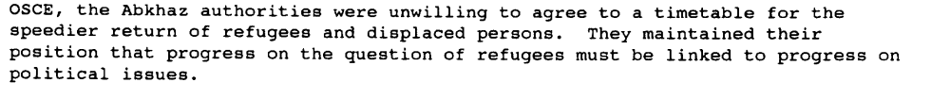s/1995/181

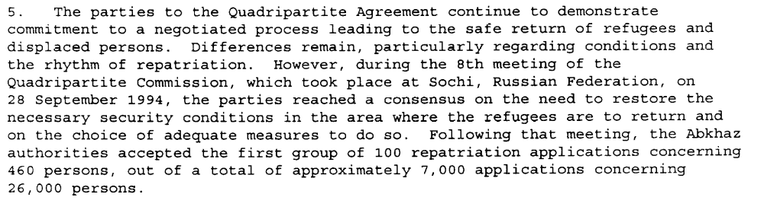s/1994/1160, p. 2

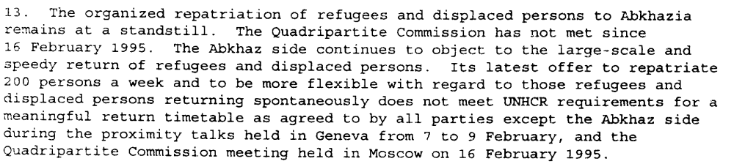s/1995/181

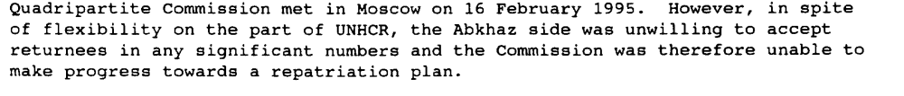S/1995/342

Assessment

Medium-term compliance
No or marginal compliance (1) | Medium low compliance (2) | Medium high compliance (3) | Full or almost full compliance (4)

Considerations underlying the assessment

Depth of demand

Assessment

Level of depth of demand
Low depth of demand (1) | Medium depth of demand (2) | High depth of demand (3)

Considerations underlying the assessment

Level of confidence about coding decisions

Level of confidence about coding decision
Extremely high | High | Moderate

Comments to IPI (if any)

Civil war in Georgia

UNSC Resolution: | 906
Date of adoption: | 25-Mar-1994
Operative paragraph: | 4
Demand number: | 906.0411

David Siroky

Wording of demand
resume negotiations as soon as possible and achieve substantive progress towards a political settlement, including on the political status of Abkhazia,

List of addressees of the demand

Government of Georgia, Abkhazia

Short-term compliance

Description of the addressee(s)’ conduct

“The Abkhaz side declined to sign any document that included recognition of Georgia’s territorial integrity (S/1994/253, p. 2, par. 9)”

“...it proved impossible to obtain a document that would be signed by both parties and in which the sovereignty and territorial integrity of the Republic of Georgia would be recognized by all concerned (S/1994/253/p. 3 par. 11)”

“The Abkhaz side, however, denies that it has at present any territorial links with the Republic of Georgia, insists on being treated as an equal party to the negotiations on political status and says that it is prepared to consider the matter of recognition of territorial integrity once the outcome of political negotiations is known, but not as a precondition for those negotiations (S/1994/312 p. 2, par. 7)”

Assessment

Short-term compliance
No or marginal compliance (1) | Medium low compliance (2) | Medium high compliance (3) | Full or almost full compliance (4)

Considerations underlying the assessment

Medium-term compliance

Description of the addressee(s)’ conduct

“On 26 Nov. 1994 the Supreme Soviet of Abkhazia adopted a constitution for Abkhazia which declared Abkhazia a “sovereign democratic State...Ardzinba was inaugurated President of the Republic on 6 Dec 1994 (S/1995/10 par 4)”

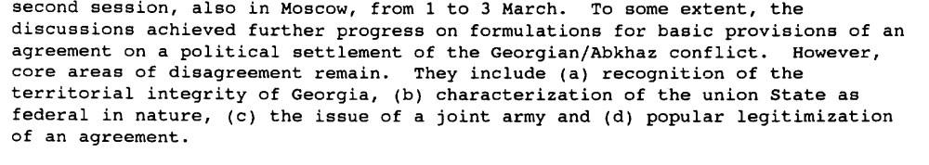s/1995/181

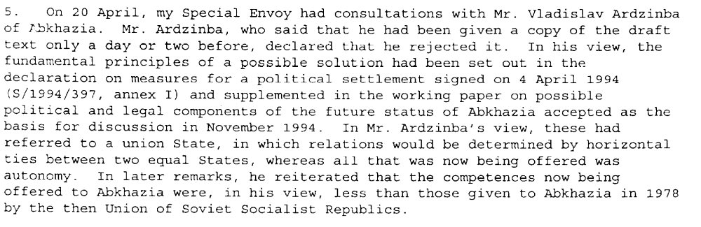s/1995/342

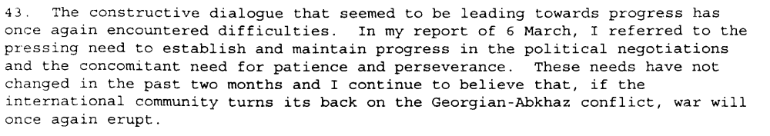s/1995/342

Assessment

Medium-term compliance
No or marginal compliance (1) | Medium low compliance (2) | Medium high compliance (3) | Full or almost full compliance (4)

Considerations underlying the assessment

Depth of demand

Assessment

Level of depth of demand
Low depth of demand (1) | Medium depth of demand (2) | High depth of demand (3)

Considerations underlying the assessment

Level of confidence about coding decisions

Level of confidence about coding decision
Extremely high | High | Moderate

Comments to IPI (if any)

Civil war in Georgia

UNSC Resolution: | 906
Date of adoption: | 25-Mar-1994
Operative paragraph: | 7
Demand number: | 906.0711

David Siroky

Wording of demand

take all necessary steps to ensure the security of UNOMIG personnel and its freedom of movement throughout the territory of the Republic of Georgia

List of addressees of the demand

Government of Georgia, Abkhazia

Short-term compliance

Description of the addressee(s)’ conduct

“UNOMIG observers, being unarmed, remain unable to conduct patrols in the Gali district, south of the Ochamchira-Tkvarcheli line, for lack of security caused by roving uncontrolled armed elements (S/1994/253/p. 3 par. 14)”

“Safe access was possible only with military escorts, which were
not provided until 24 February, at which time UNOMIG observers were able to visit certain areas in the Gali district (S/1994/253/p. 4 par. 18)”

“The sad fact is that the conditions have not yet been fulfilled for the deployment of a UN force in Abkhazia (S/1994/529 p. 5, par. 20)”

Assessment

Short-term compliance
No or marginal compliance (1) | Medium low compliance (2) | Medium high compliance (3) | Full or almost full compliance (4)

Considerations underlying the assessment

Medium-term compliance

Description of the addressee(s)’ conduct

“The mission has been receiving cooperation from both the Gov of Georgia and the Abkhaz authorities....the military observers enjoy the freedom of movement necessary to perform their tasks (S/1995/10, par. 20).”

“ ...cooperation with both sides has continued at an acceptable level (S/1995/657, par. 32) ”

“ There have been a number of incidents of armed robberies of UNOMIG personnel on patrol...(S/1995/657, par. 33)”

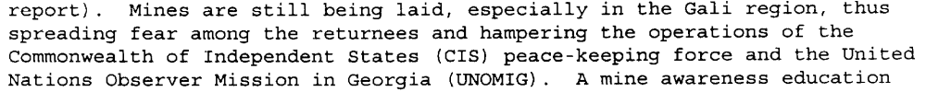s/1994.1160

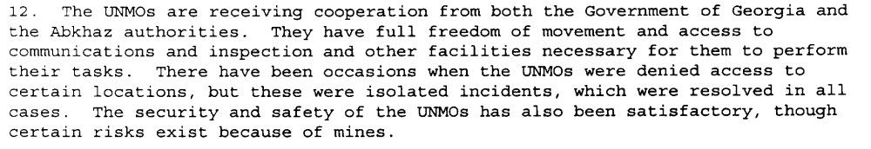s/1994/1160

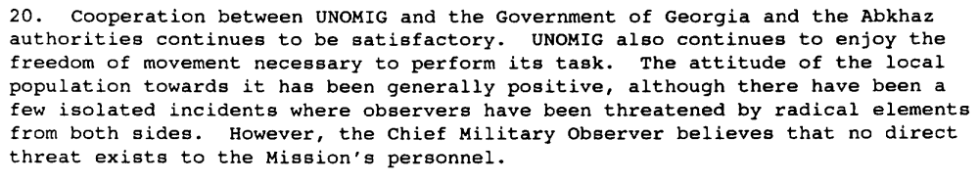s/1995/181

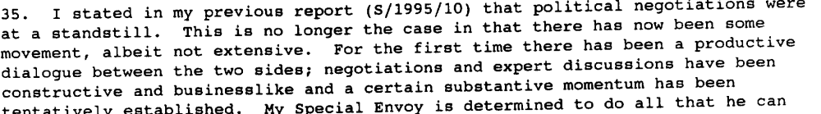s/1995/181

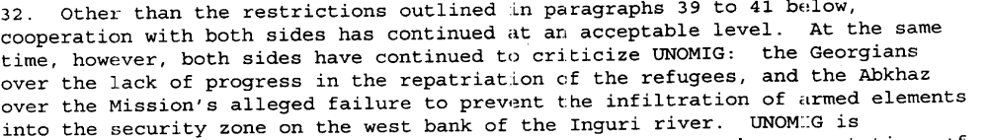s/1995/657

Assessment

Medium-term compliance
No or marginal compliance (1) | Medium low compliance (2) | Medium high compliance (3) | Full or almost full compliance (4)

Considerations underlying the assessment

Depth of demand

Assessment

Level of depth of demand
Low depth of demand (1) | Medium depth of demand (2) | High depth of demand (3)

Considerations underlying the assessment

Level of confidence about coding decisions

Level of confidence about coding decision
Extremely high | High | Moderate

Comments to IPI (if any)

